Coimbatore Institute of Technology - Web Application Development - Coding Round

**Question**:

Develop PHP application using CodeIgniter or any other framework to complete the below.

Have Menus like this

1) DashBoard

2) Today’s Answered/Missed

3) Customer List

**Answer**

1)Dashboard page

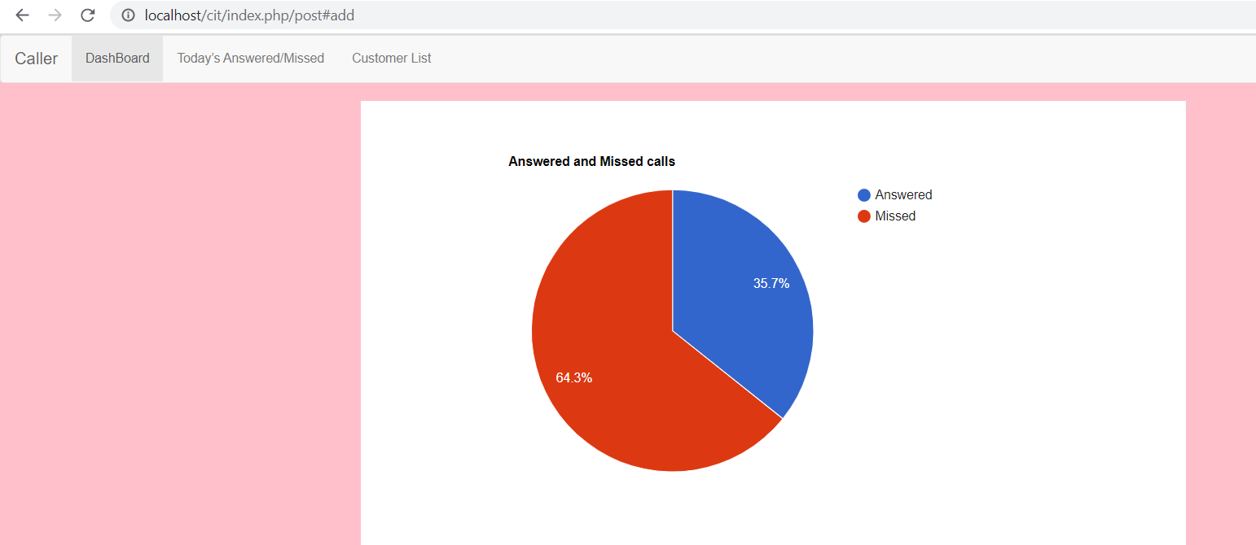

2)Todays answered call

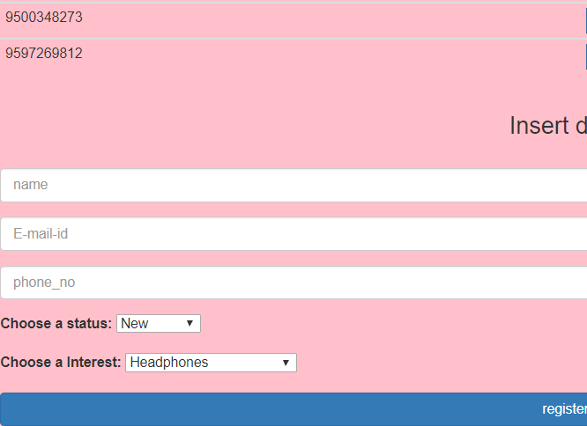

3)Customer details

